
PRISMA 2020 Checklist
Section and Topic | Item # | Checklist item | Location where item is reported
TITLE
Title | 1 | Identify the report as a systematic review. | #1
ABSTRACT
Abstract | 2 | See the PRISMA 2020 for Abstracts checklist. | #2
INTRODUCTION
Rationale | 3 | Describe the rationale for the review in the context of existing knowledge. | #3–4
Objectives | 4 | Provide an explicit statement of the objective(s) or question(s) the review addresses. | #4
METHODS
Eligibility criteria | 5 | Specify the inclusion and exclusion criteria for the review and how studies were grouped for the syntheses. | #4
Information sources | 6 | Specify all databases, registers, websites, organisations, reference lists and other sources searched or consulted to identify studies. Specify the date when each source was last searched or consulted. | #4–5
Search strategy | 7 | Present the full search strategies for all databases, registers and websites, including any filters and limits used. | #4–5
Selection process | 8 | Specify the methods used to decide whether a study met the inclusion criteria of the review, including how many reviewers screened each record and each report retrieved, whether they worked independently, and if applicable, details of automation tools used in the process. | #4–5
Data collection process | 9 | Specify the methods used to collect data from reports, including how many reviewers collected data from each report, whether they worked independently, any processes for obtaining or confirming data from study investigators, and if applicable, details of automation tools used in the process. | #5
Data items | 10a | List and define all outcomes for which data were sought. Specify whether all results that were compatible with each outcome domain in each study were sought (e.g. for all measures, time points, analyses), and if not, the methods used to decide which results to collect. | #5–6
Data items | 10b | List and define all other variables for which data were sought (e.g. participant and intervention characteristics, funding sources). Describe any assumptions made about any missing or unclear information. | #5–7  Table 1
Study risk of bias assessment | 11 | Specify the methods used to assess risk of bias in the included studies, including details of the tool(s) used, how many reviewers assessed each study and whether they worked independently, and if applicable, details of automation tools used in the process. | #6
Effect measures | 12 | Specify for each outcome the effect measure(s) (e.g. risk ratio, mean difference) used in the synthesis or presentation of results. | #5–6
Synthesis methods | 13a | Describe the processes used to decide which studies were eligible for each synthesis (e.g. tabulating the study intervention characteristics and comparing against the planned groups for each synthesis (item #5)). | Table 2
Synthesis methods | 13b | Describe any methods required to prepare the data for presentation or synthesis, such as handling of missing summary statistics, or data conversions. | #5–6
Synthesis methods | 13c | Describe any methods used to tabulate or visually display results of individual studies and syntheses. | Table 1 & 2
Synthesis methods | 13d | Describe any methods used to synthesize results and provide a rationale for the choice(s). If meta-analysis was performed, describe the model(s), method(s) to identify the presence and extent of statistical heterogeneity, and software package(s) used. | #5–6
Synthesis methods | 13e | Describe any methods used to explore possible causes of heterogeneity among study results (e.g. subgroup analysis, meta-regression). | #6
Synthesis methods | 13f | Describe any sensitivity analyses conducted to assess robustness of the synthesized results. | Not applicable
Reporting bias assessment | 14 | Describe any methods used to assess risk of bias due to missing results in a synthesis (arising from reporting biases). | #6
Certainty assessment | 15 | Describe any methods used to assess certainty (or confidence) in the body of evidence for an outcome. | Not applicable
RESULTS
Study selection | 16a | Describe the results of the search and selection process, from the number of records identified in the search to the number of studies included in the review, ideally using a flow diagram. | #7  Figure 1
Study selection | 16b | Cite studies that might appear to meet the inclusion criteria, but which were excluded, and explain why they were excluded. | #7  Figure 1
Study characteristics | 17 | Cite each included study and present its characteristics. | #6–8  Table 1 & 2
Risk of bias in studies | 18 | Present assessments of risk of bias for each included study. | #10  Figure 2
Results of individual studies | 19 | For all outcomes, present, for each study: (a) summary statistics for each group (where appropriate) and (b) an effect estimate and its precision (e.g. confidence/credible interval), ideally using structured tables or plots. | #13–20  Figure 3–8
Results of syntheses | 20a | For each synthesis, briefly summarise the characteristics and risk of bias among contributing studies. | Figure 2
Results of syntheses | 20b | Present results of all statistical syntheses conducted. If meta-analysis was done, present for each the summary estimate and its precision (e.g. confidence/credible interval) and measures of statistical heterogeneity. If comparing groups, describe the direction of the effect. | #13–20  Figure 3–8
Results of syntheses | 20c | Present results of all investigations of possible causes of heterogeneity among study results. | #13–20
Results of syntheses | 20d | Present results of all sensitivity analyses conducted to assess the robustness of the synthesized results. | Not applicable
Reporting biases | 21 | Present assessments of risk of bias due to missing results (arising from reporting biases) for each synthesis assessed. | #12  Figure 2
Certainty of evidence | 22 | Present assessments of certainty (or confidence) in the body of evidence for each outcome assessed. | #13–20  Figure 3–8
DISCUSSION
Discussion | 23a | Provide a general interpretation of the results in the context of other evidence. | #20–21
Discussion | 23b | Discuss any limitations of the evidence included in the review. | #23–24
Discussion | 23c | Discuss any limitations of the review processes used. | #23–24
Discussion | 23d | Discuss implications of the results for practice, policy, and future research. | #21–24
OTHER INFORMATION
Registration and protocol | 24a | Provide registration information for the review, including register name and registration number, or state that the review was not registered. | Not applicable
Registration and protocol | 24b | Indicate where the review protocol can be accessed, or state that a protocol was not prepared. | Not applicable
Registration and protocol | 24c | Describe and explain any amendments to information provided at registration or in the protocol. | Not applicable
Support | 25 | Describe sources of financial or non-financial support for the review, and the role of the funders or sponsors in the review. | Not applicable
Competing interests | 26 | Declare any competing interests of review authors. | Not applicable
Availability of data, code and other materials | 27 | Report which of the following are publicly available and where they can be found: template data collection forms; data extracted from included studies; data used for all analyses; analytic code; any other materials used in the review. | Not applicable

From: Page MJ, McKenzie JE, Bossuyt PM, Boutron I, Hoffmann TC, Mulrow CD, et al. The PRISMA 2020 statement: an updated guideline for reporting systematic reviews. BMJ 2021;372:n71. doi: 10.1136/bmj.n71. This work is licensed under CC BY 4.0. To view a copy of this license, visit https://creativecommons.org/licenses/by/4.0/

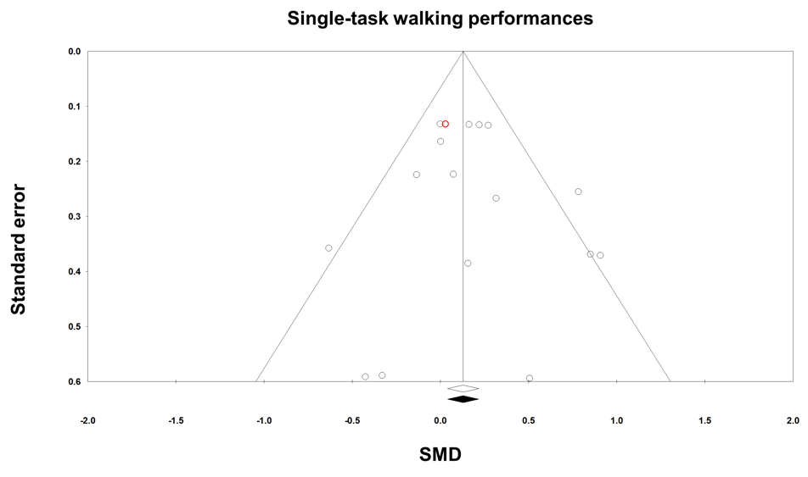
Supplementary Fig. 1. Funnel plot for single-task walking performance comparisons. The white diamond on the x-axis indicates an original overall effect size and the black diamond indicates an adjusted overall effect size after the trim and fill technique. Open circles are original data and the red circle represents overlapped two circles due to the identical values of SMD and standard error. SMD, standardized mean difference.

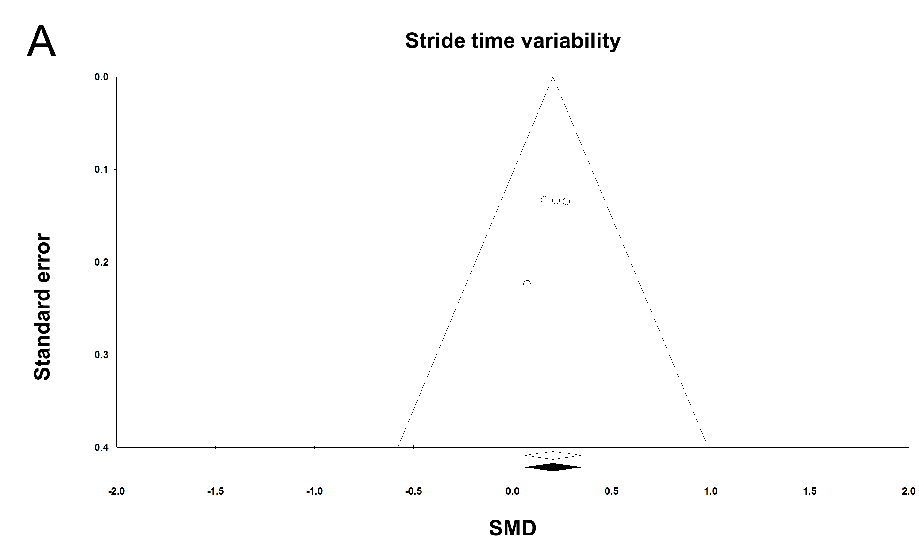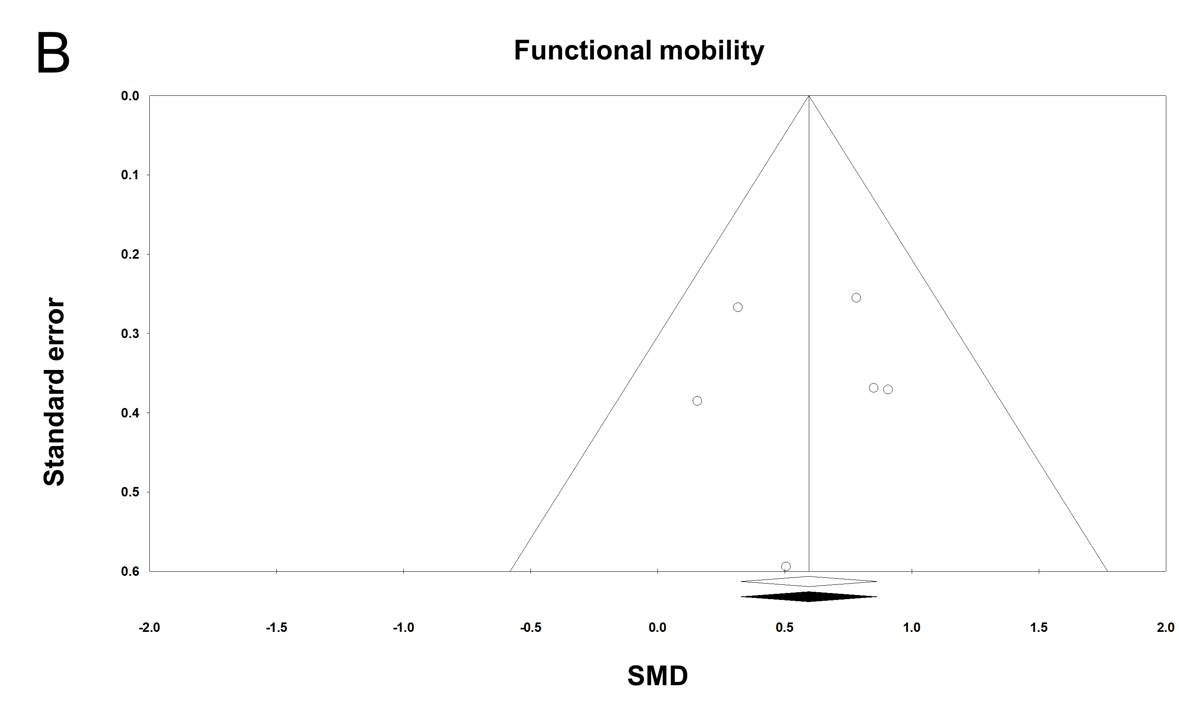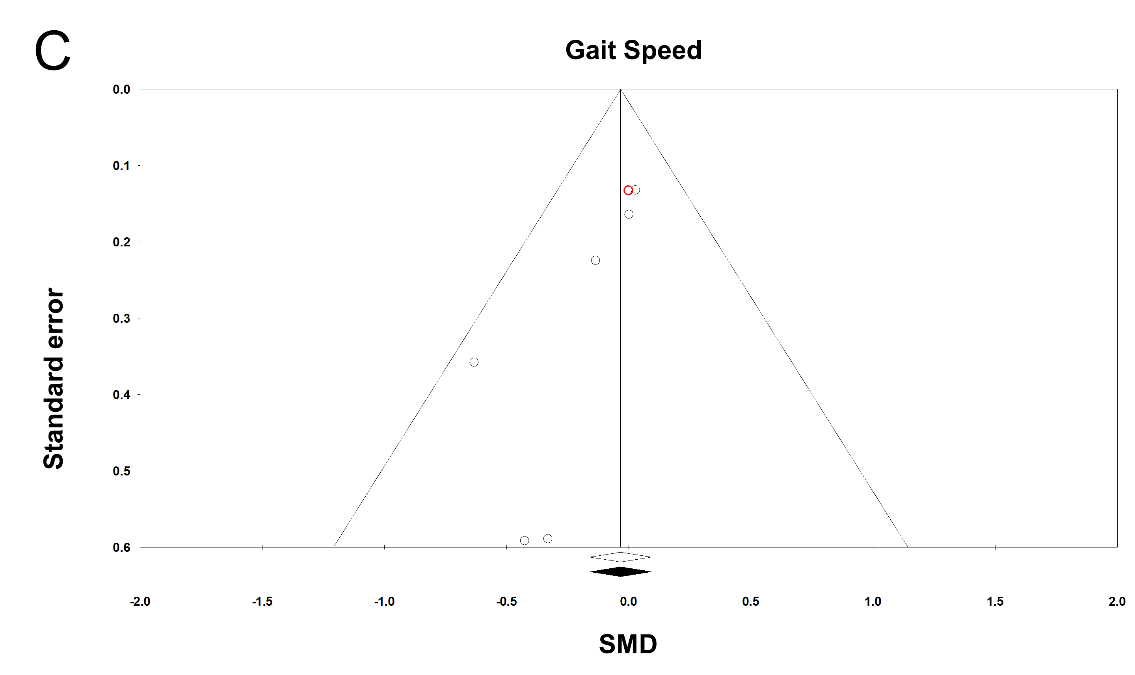
Supplementary Fig. 2. Funnel plot for each gait variable during single-task walking. (A) Stride time variability. (B) Functional mobility. (C) Gait speed. The white diamond on the x-axis indicates an original overall effect size and the black diamond indicates an adjusted overall effect size after the trim and fill technique. Open circles are original data and the red circle represents overlapped two circles due to the identical values of SMD and standard error. SMD, standardized mean difference.
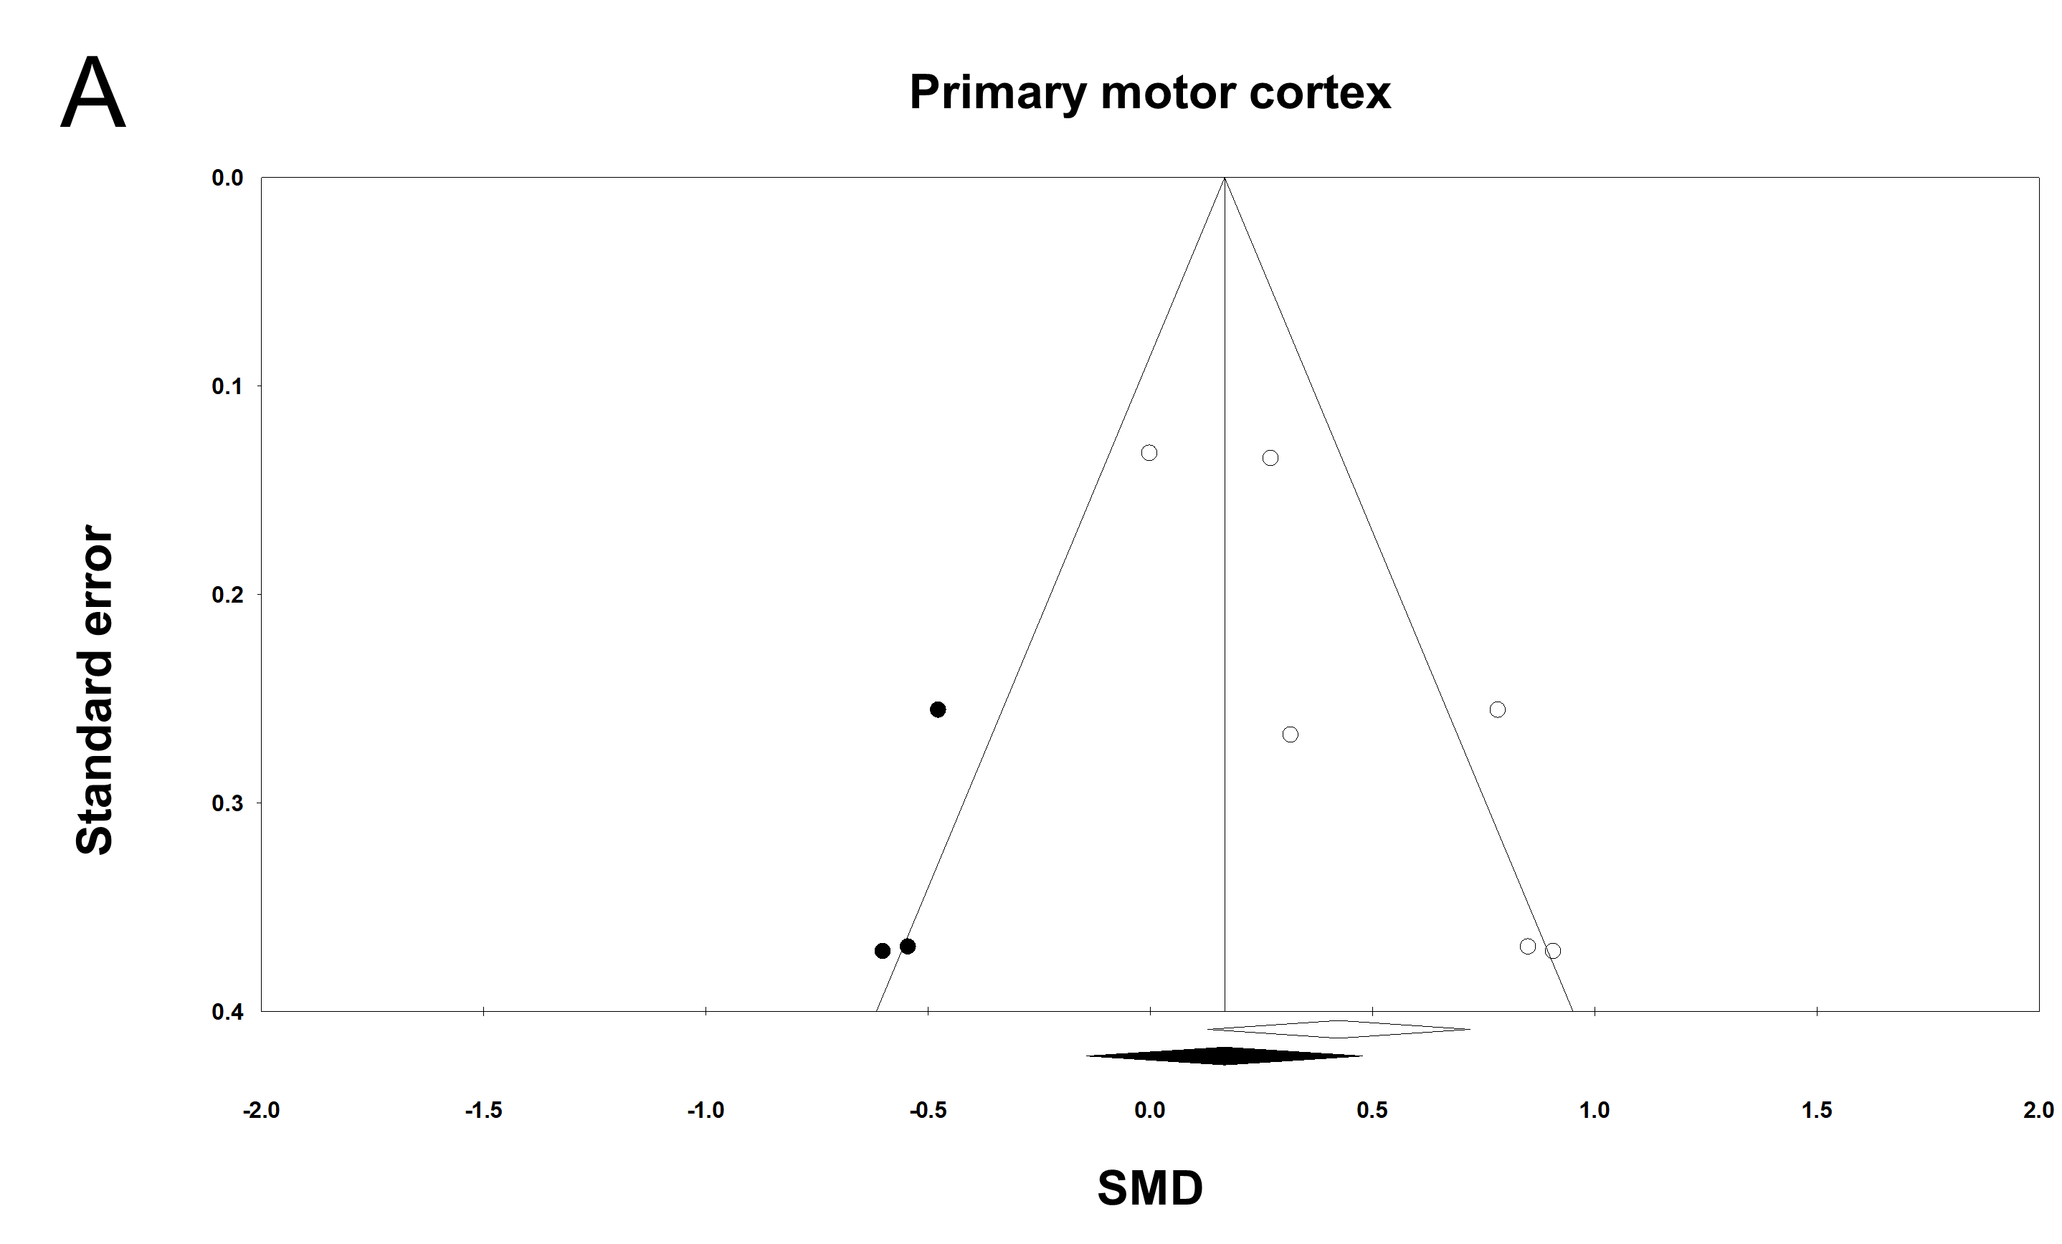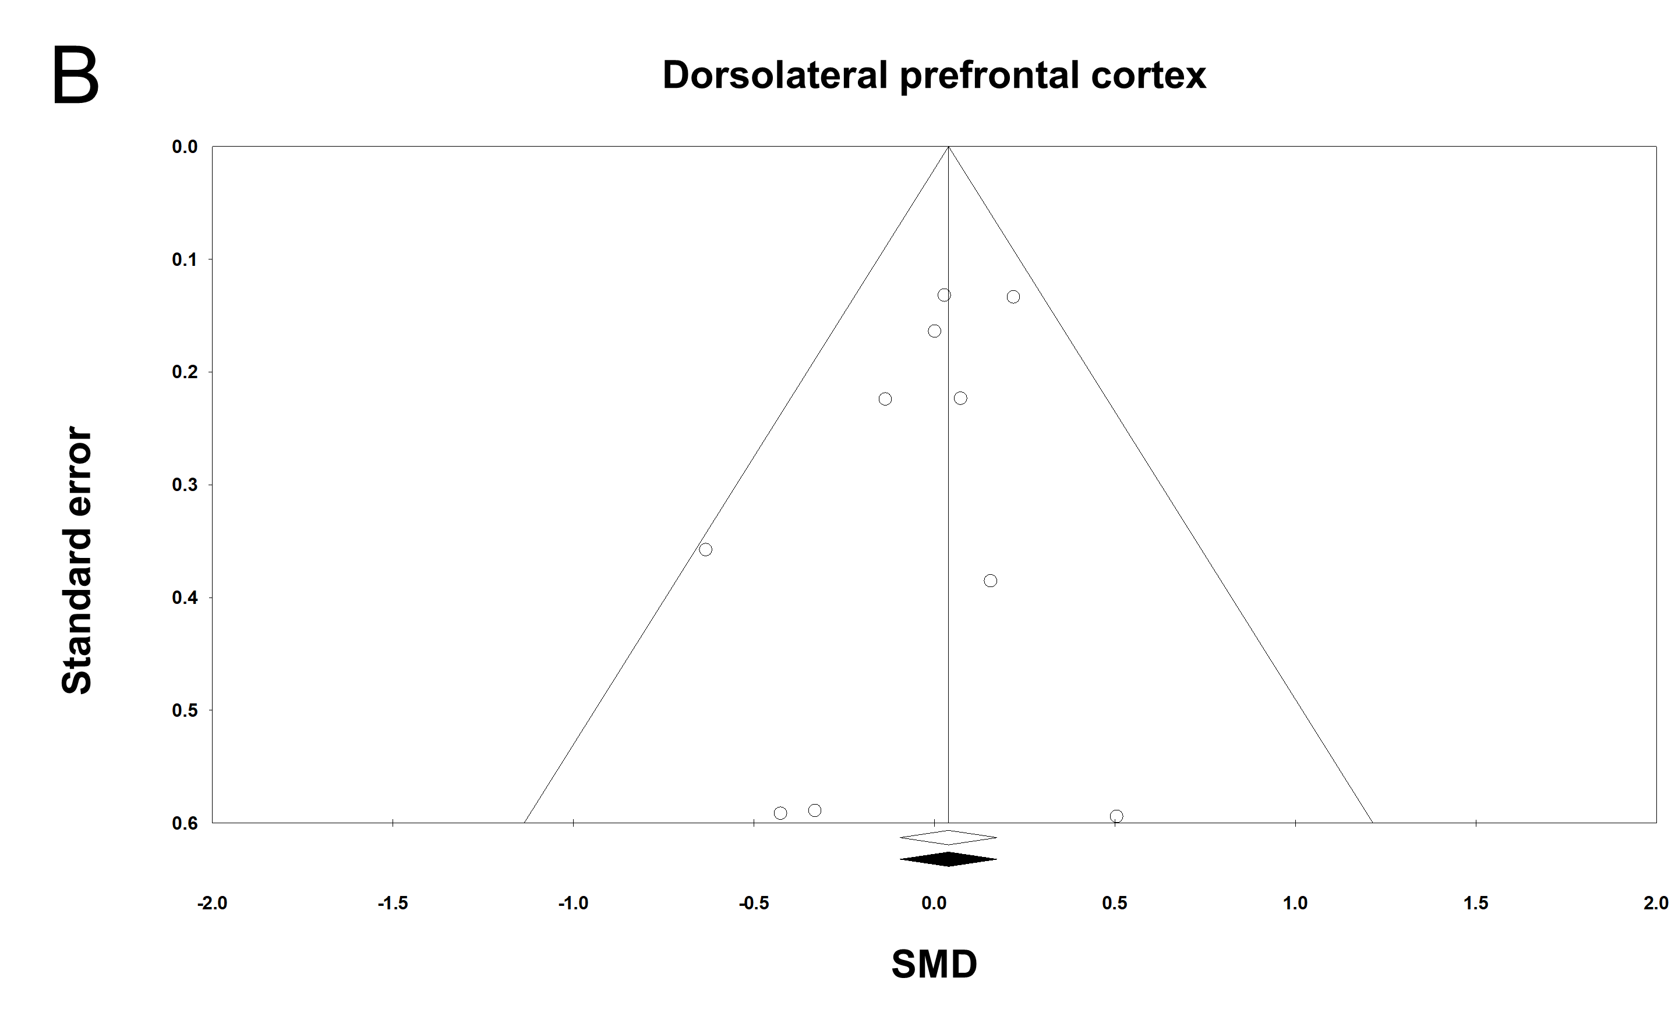
Supplementary Fig. 3. Funnel plot for targeted brain regions during single-task walking. (A) Primary motor cortex. (B) Dorsolateral prefrontal cortex. The white diamond on the x-axis indicates an original overall effect size and the black diamond indicates an adjusted overall effect size after the trim and fill technique. Solid circles are imputed filled values that are estimated to be missing due to publication bias, and open circles are original data. SMD, standardized mean difference.

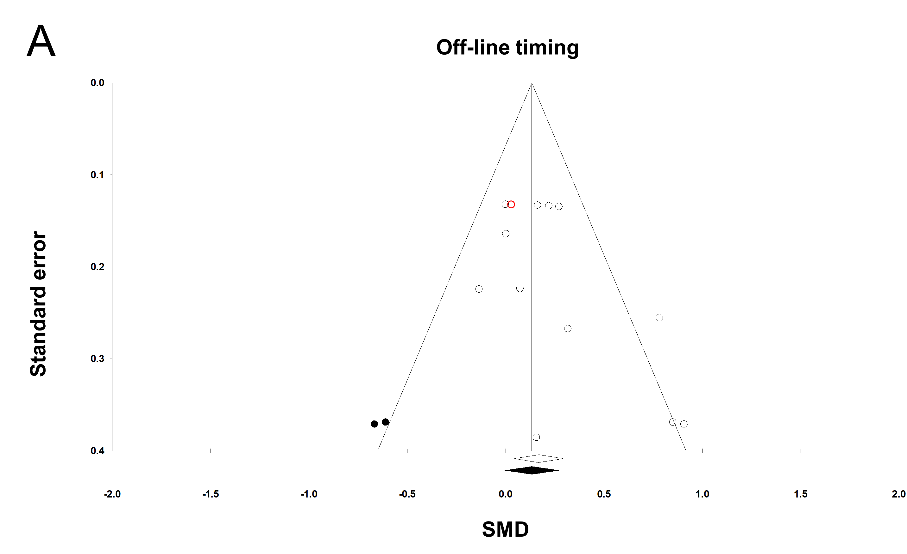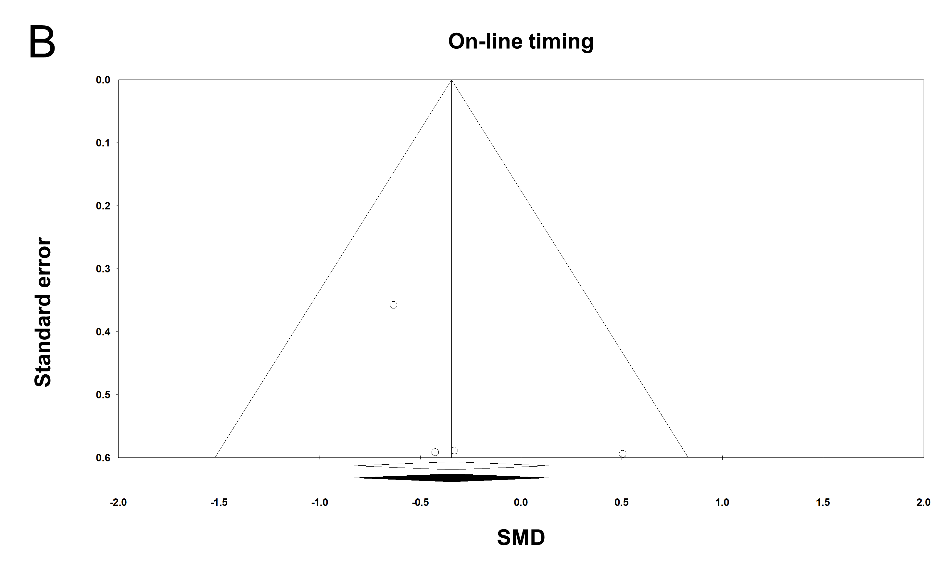
Supplementary Fig. 4. Funnel plot for stimulation timing during single-task walking. (A) Off-ling timing. (B) On-line timing. The white diamond on the x-axis indicates an original overall effect size and the black diamond indicates an adjusted overall effect size after the trim and fill technique. Solid circles are imputed filled values that are estimated to be missing due to publication bias, and open circles are original data. The red circle represents overlapped two circles due to the identical values of SMD and standard error. SMD, standardized mean difference.
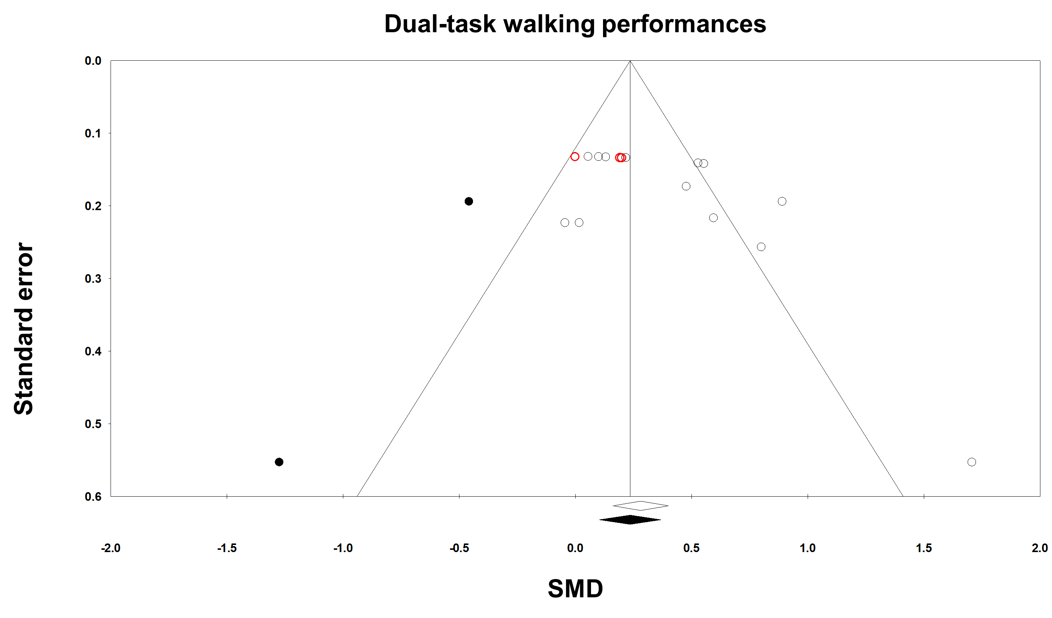
Supplementary Fig. 5. Funnel plot for dual-task walking performance comparisons. The white diamond on the x-axis indicates an original overall effect size and the black diamond indicates an adjusted overall effect size after the trim and fill technique. Solid circles are imputed filled values that are estimated to be missing due to publication bias, and open circles are original data. The red circle represents overlapped two circles due to the identical values of SMD and standard error. SMD, standardized mean difference.
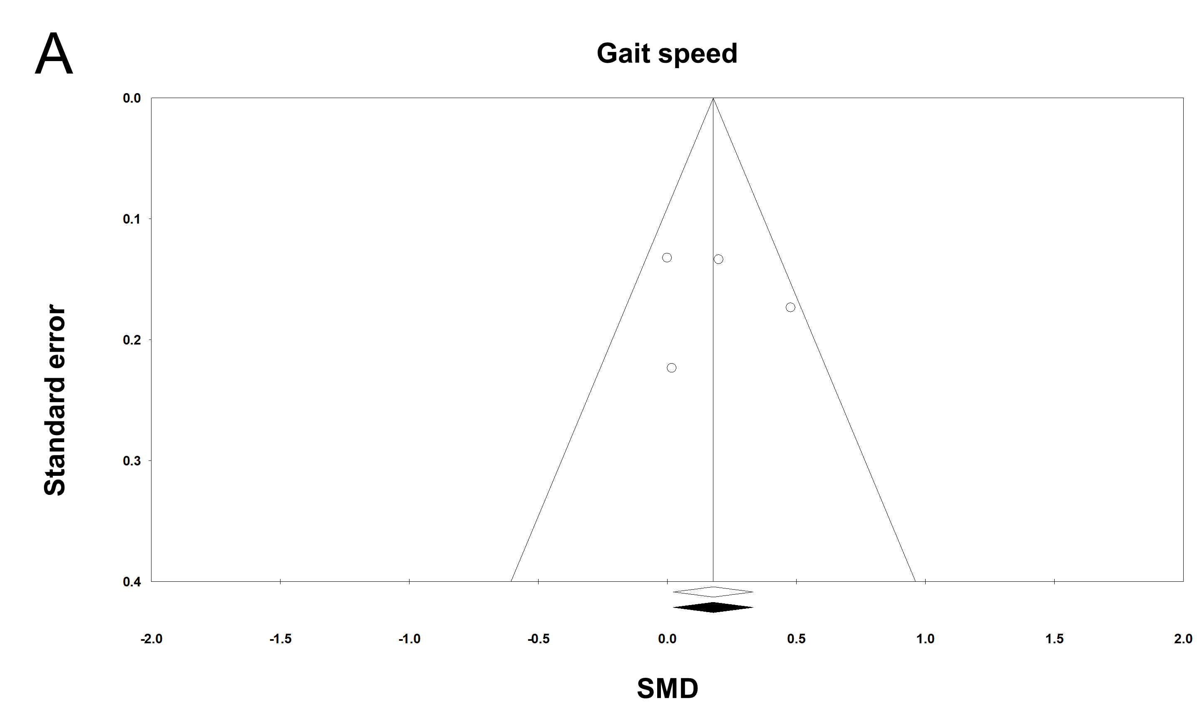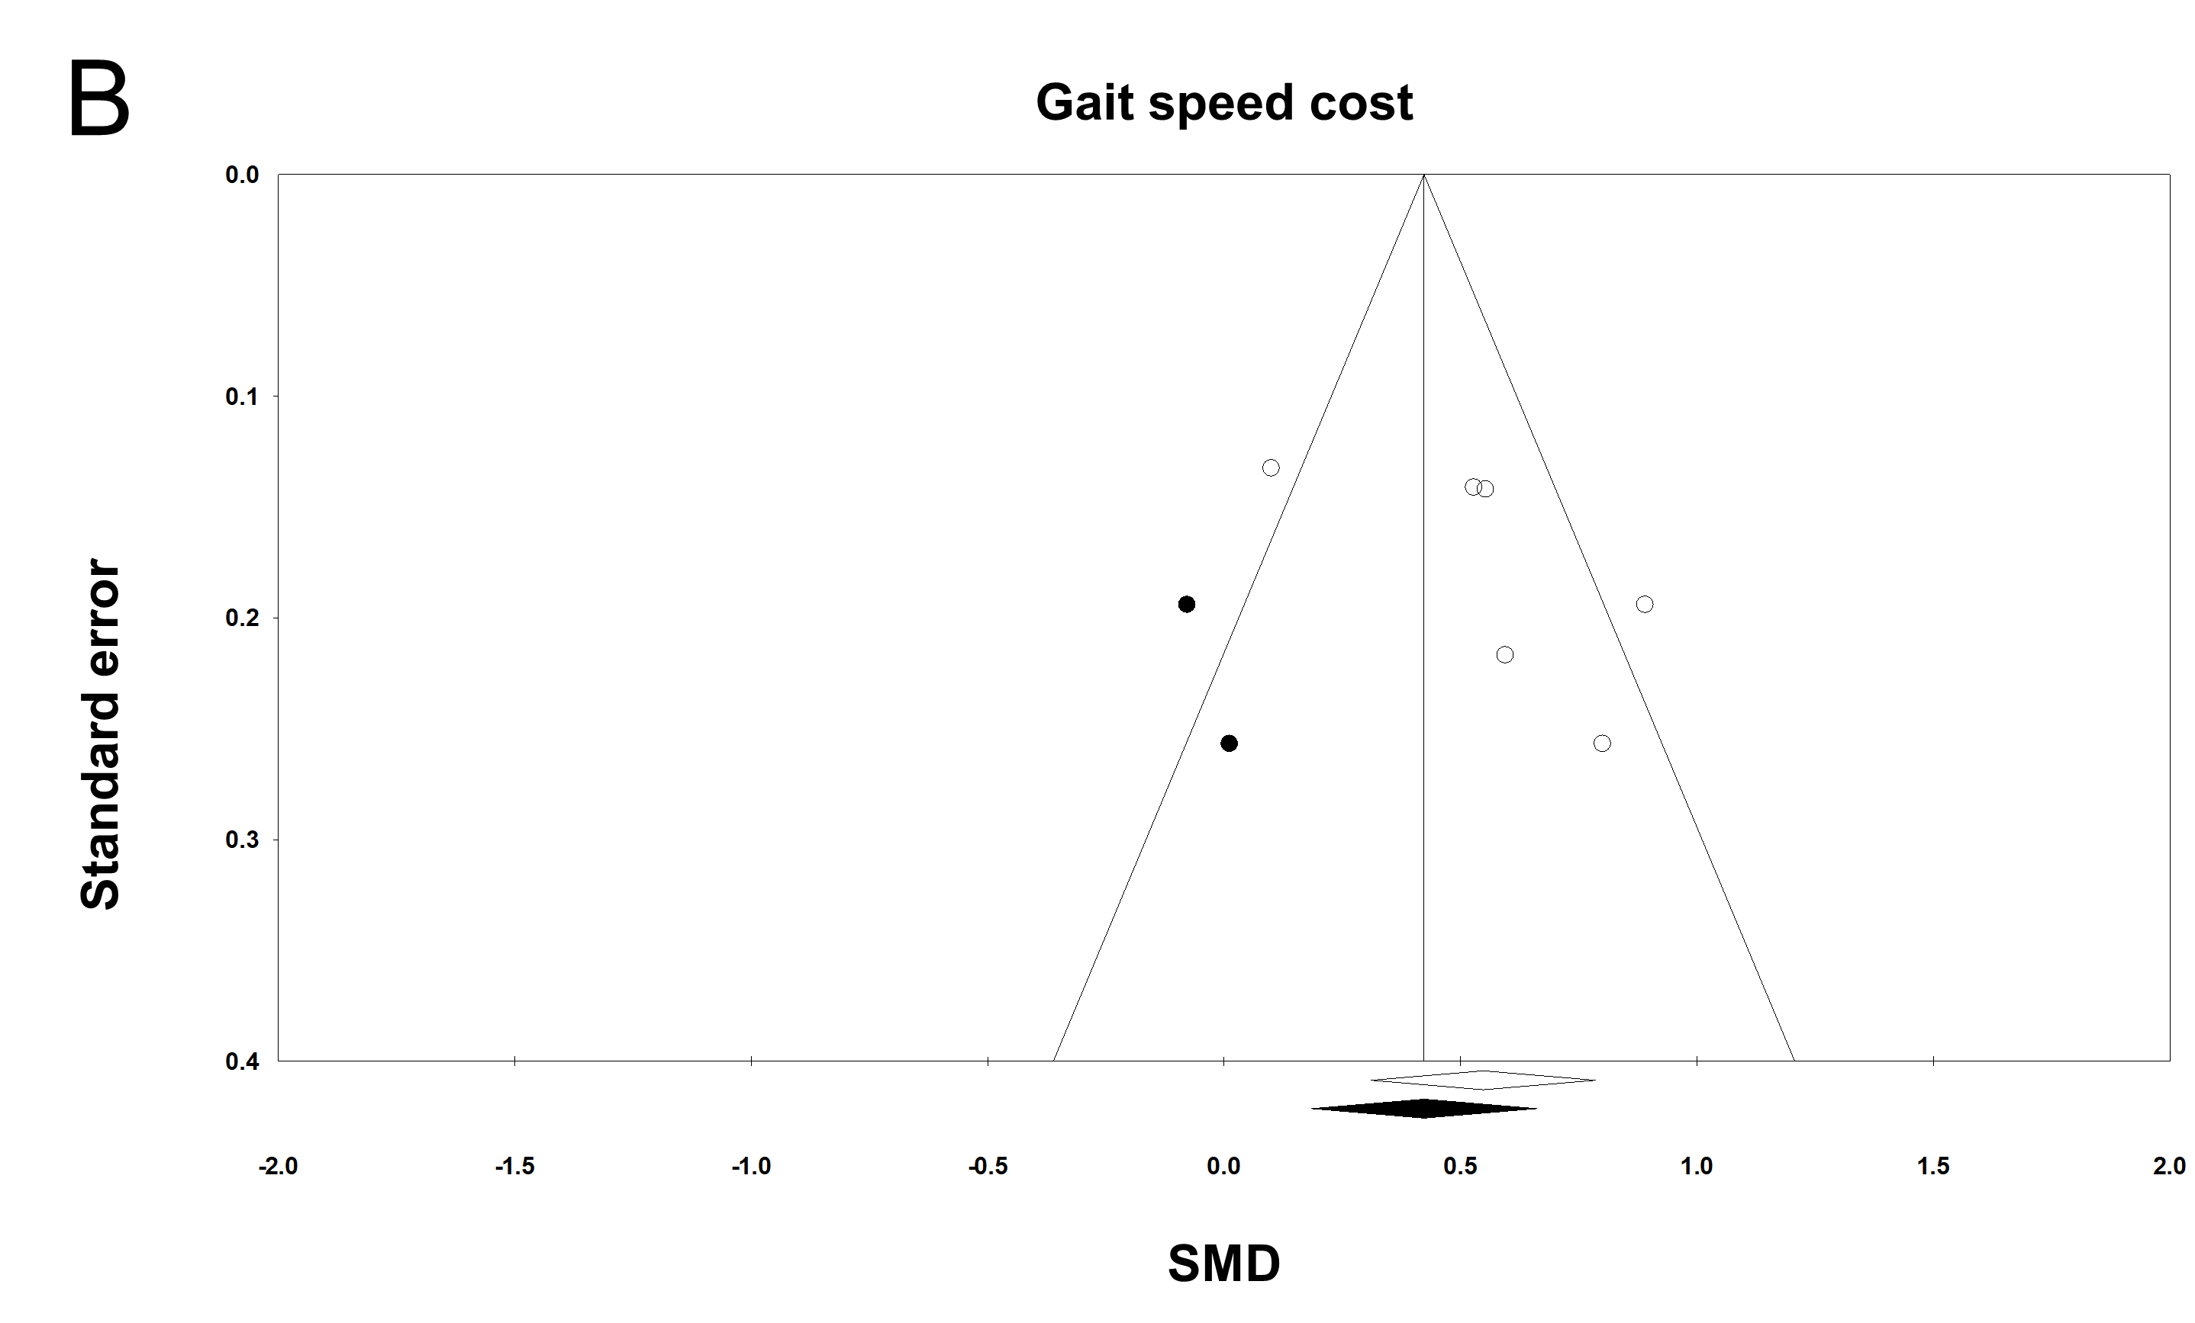
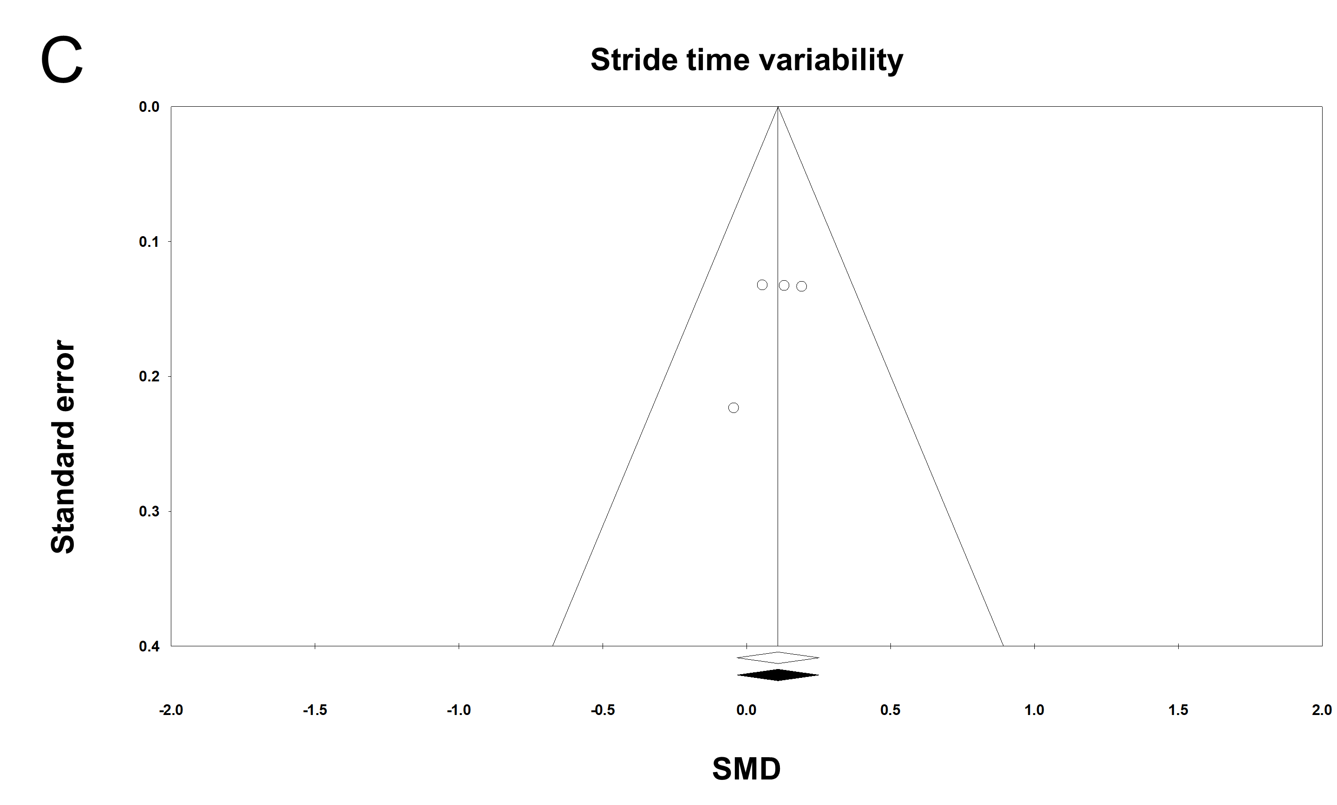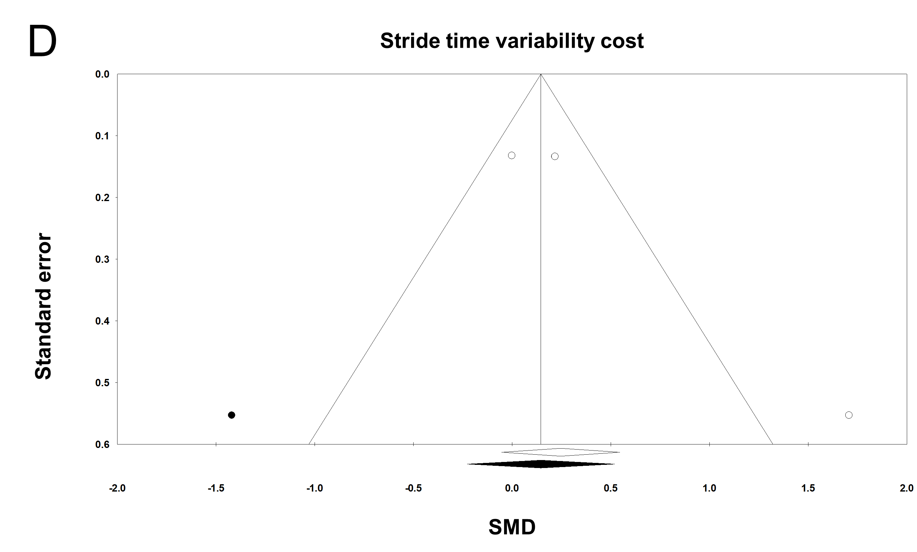
Supplementary Fig. 6. Funnel plot for each gait variable during single-task walking. (A) Gait speed. (B) Gait speed cost. (C) Stride time variability. (D) Stride time variability cost. The white diamond on the x-axis indicates an original overall effect size and the black diamond indicates an adjusted overall effect size after the trim and fill technique. Solid circles are imputed filled values that are estimated to be missing due to publication bias, and open circles are original data. SMD, standardized mean difference.
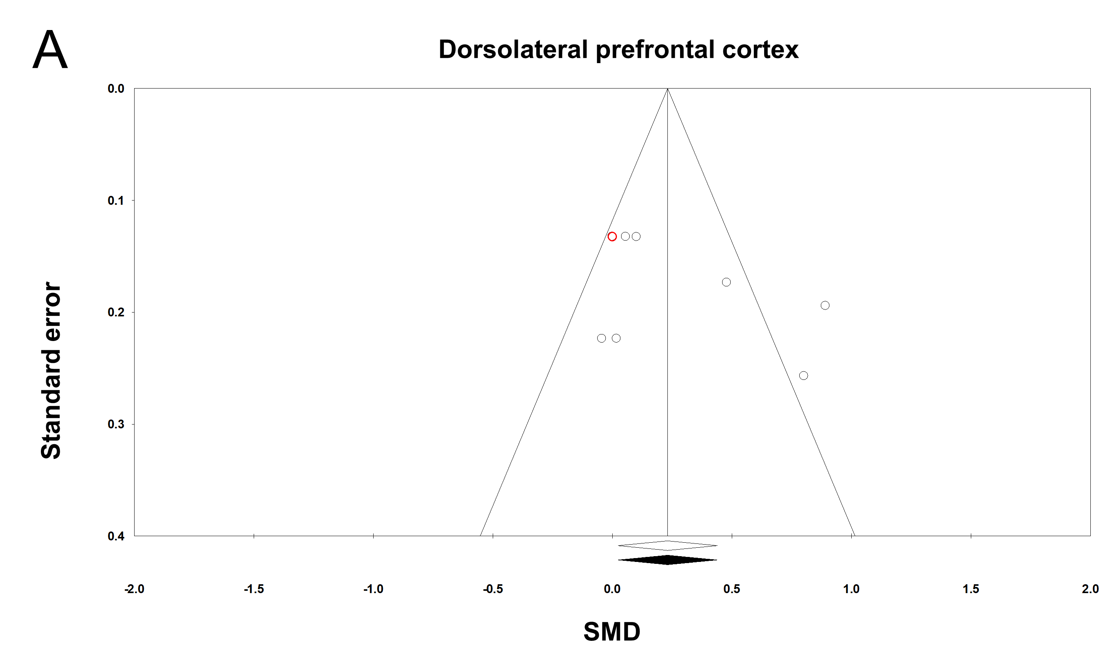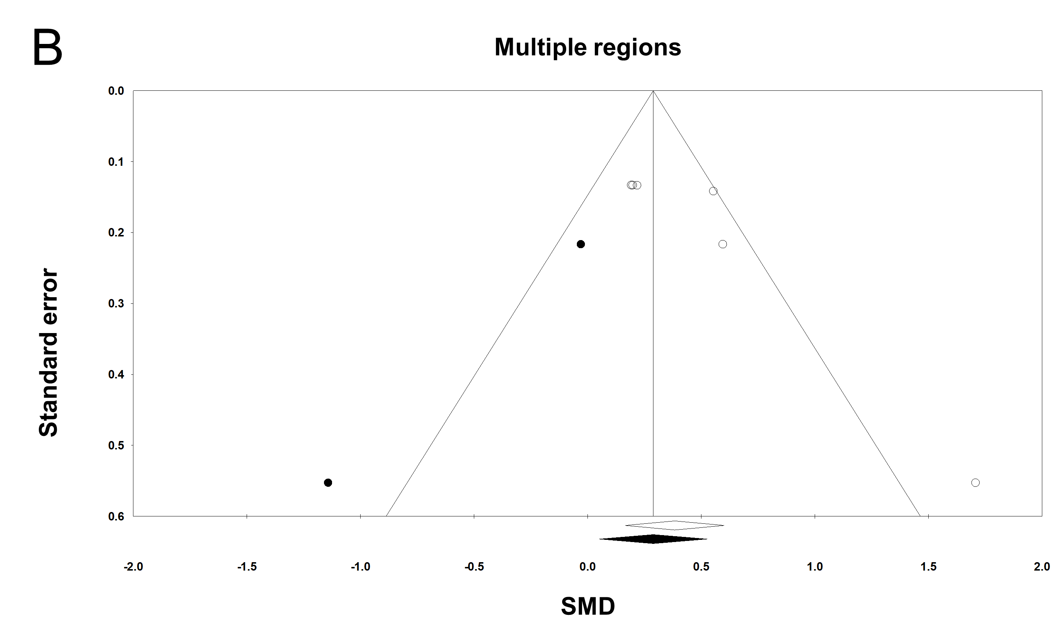
Supplementary Fig. 7. Funnel plot for targeted brain regions during dual-task walking. (A) Dorsolateral prefrontal cortex. (B) Multiple regions. The white diamond on the x-axis indicates an original overall effect size and the black diamond indicates an adjusted overall effect size after the trim and fill technique. Solid circles are imputed filled values that are estimated to be missing due to publication bias, and open circles are original data. The red circle represents overlapped two circles due to the identical of SMD and standard error. SMD, standardized mean difference.
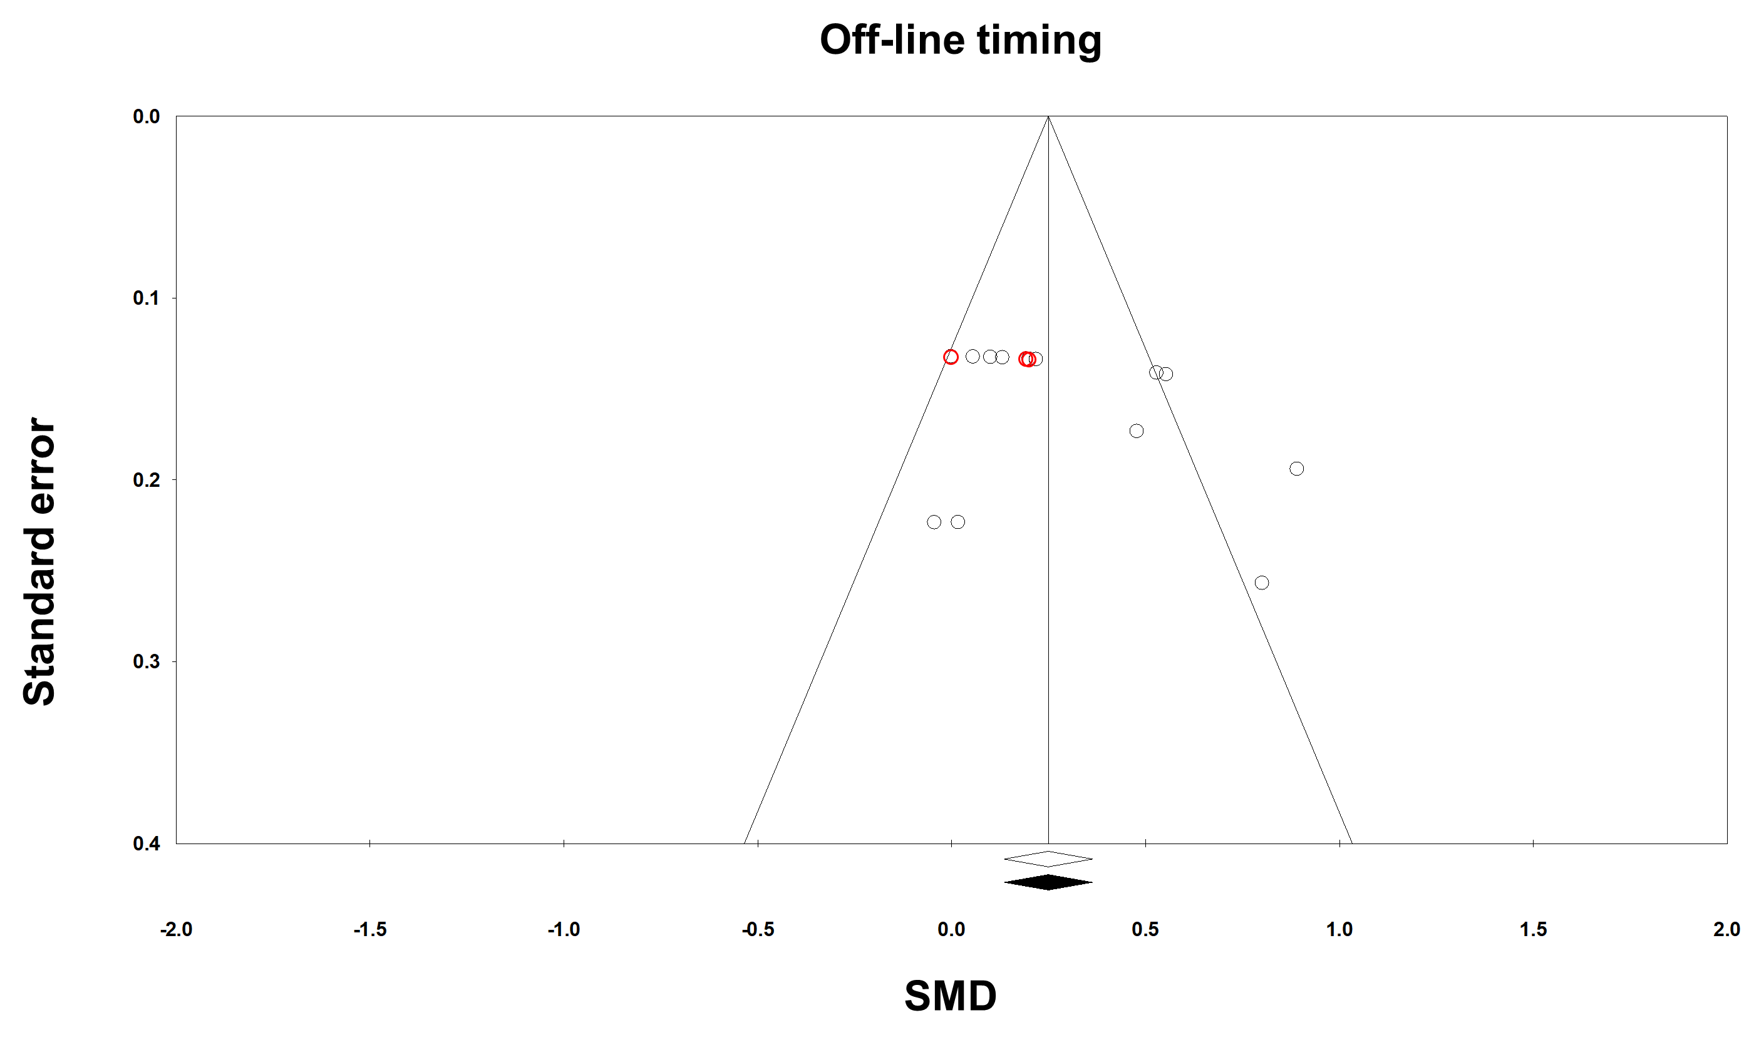
Supplementary Fig. 8. Funnel plot for off-line timing during dual-task walking. The white diamond on the x-axis indicates an original overall effect size and the black diamond indicates an adjusted overall effect size after the trim and fill technique. Open circles are original data and the red circle represents overlapped two circles due to the identical values of SMD and standard error. SMD, standardized mean difference.

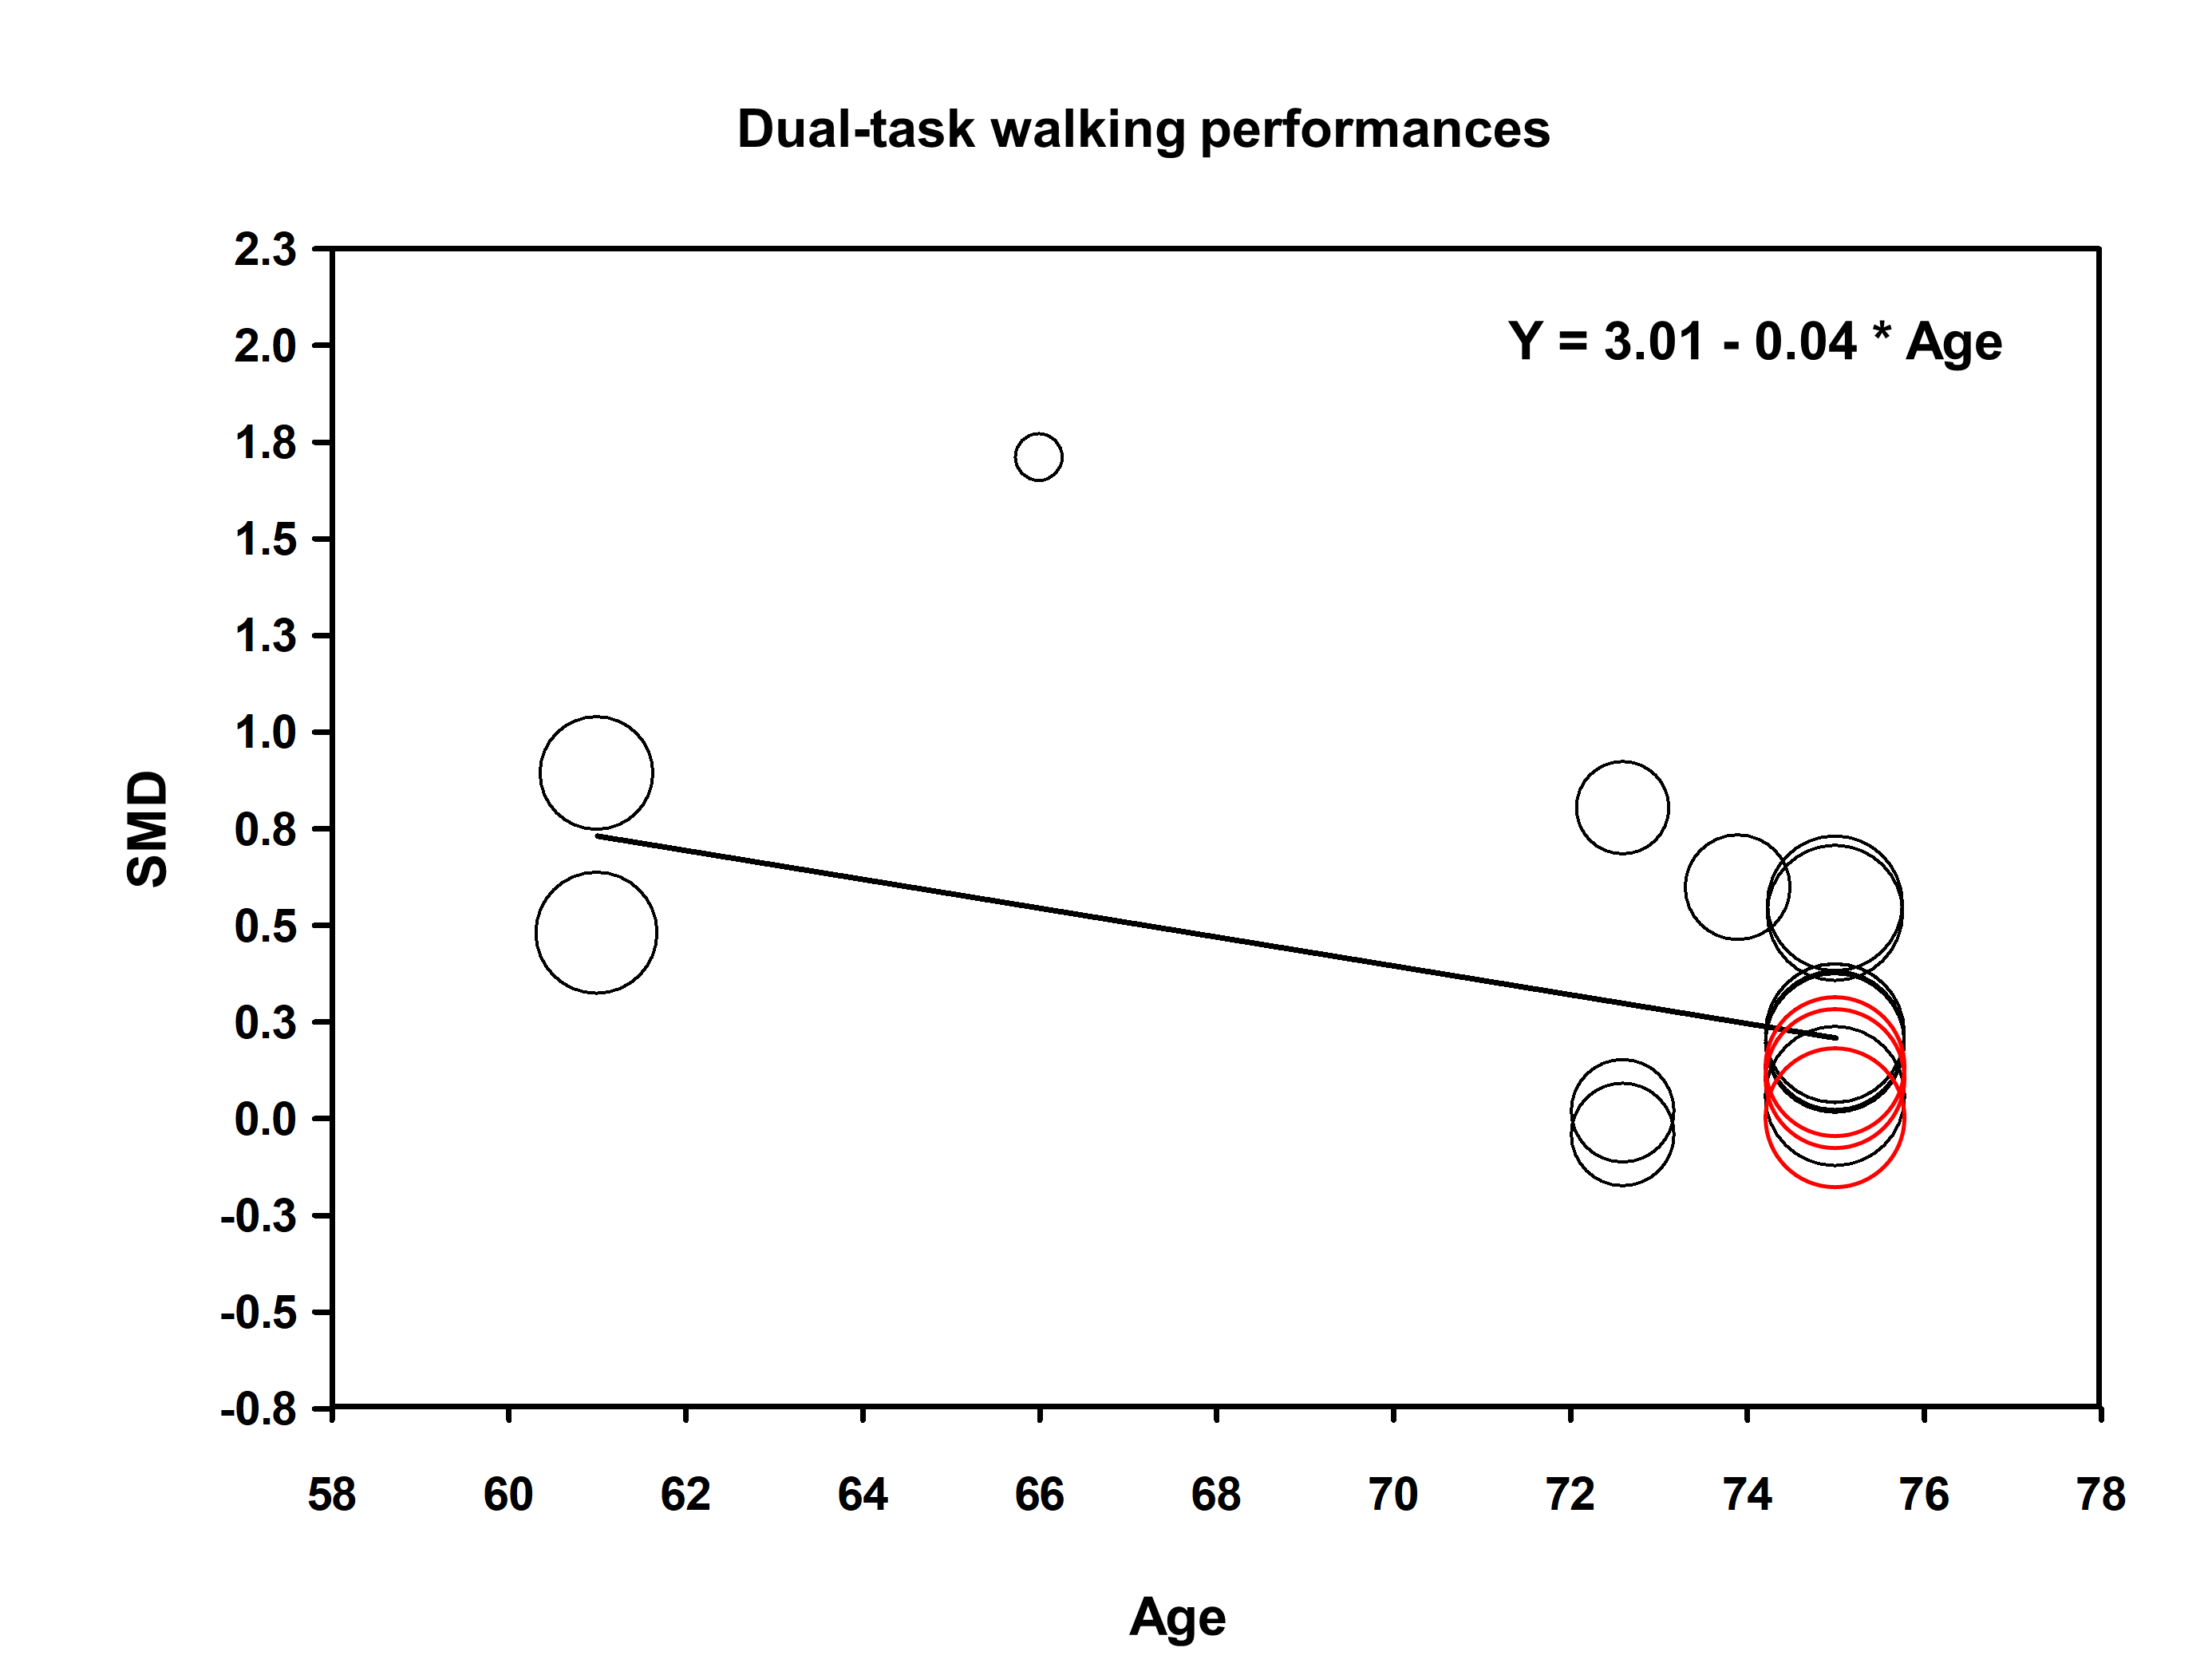
Supplementary Fig. 9. Meta-regression analysis finding. tDCS effects on dual-task walking performances versus age. Open circles are original data and the red circle represents overlapped two circles due to the identical values of SMD and standard error. * indicates multiplication. SMD, standardized mean difference.

